**ChessGUI**

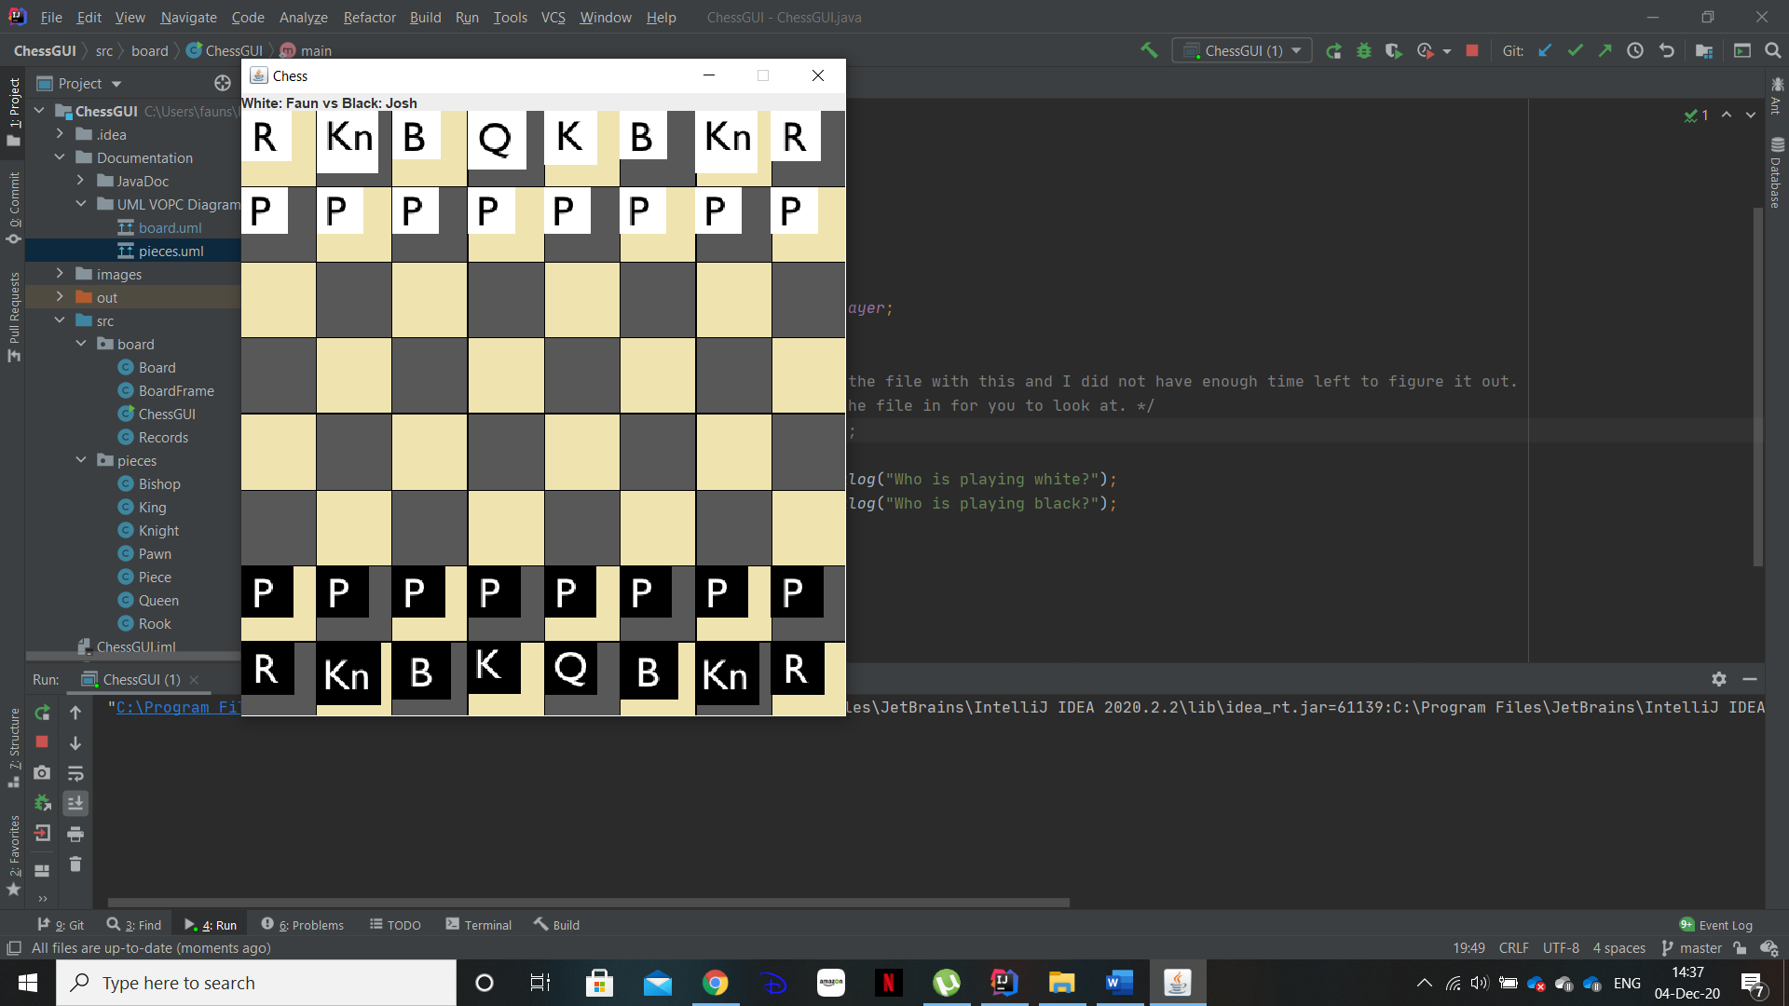

This ChessGUI program work by overlaying a grid over an image of a chess board that is pull from the image file the, piece on both coloured teams are then set to their starting positions.

Each piece is represented by an image and has a set of rules written for them, that determine if they can move to the selected destination and if there is a piece at that destination if they a take that piece.

Each piece is set so they can not take from their own team no “friendly fire” essentially.

The king is set so that if it is taken then the game ends and then team that took the others king wins basic elements of the game are recorded such as who on the match and in how many moves it was won.

Had I more time to work on the then I would have like to implement a promotion element to the pawn piece. In chess if the pawn gets to the other side of the board the it can be promoted to either a ‘Rook’, ‘Knight’, ‘Bishop’ or even a ‘Queen’ so it is possible to get a second queen if your smart about your play. I would have done the by having a bit of code that keeps an eye out for if the Pawns y coordinates reach the other side and the give the player a choice for what they would like their Pawn promoted to.

And secondly I would like to have gotten the code for the king to be unable to move it-self into a position of check, now that it currently cannot do that is no hugh issue as no competent chess player would move their king into a position of check but in other online digital chess games that I have played you can’t move your king into a position of check, so this is something I would have liked to have gotten working.